**Problem Statement:**

The objective of this business case is to analyze a Netflix content dataset and derive actionable insights to help Netflix decide what types of shows/movies to focus on and how to expand effectively across countries.

**Dataset Overview:**

The dataset contains 8,807 entries with 12 attributes such as show ID, type, title, director, cast, country, release year, rating, duration, and genre.

**Missing Values:**

* ‘director’: 2,634 missing
* ‘cast’: 825 missing
* ‘country’: 831 missing
* ‘date_added’: 10 missing
* ‘rating’: 4 missing
* ‘duration’: 3 missing

**STEP 1: Define the Problem Statement + Analyze Basic Metrics (10 Points)**

What to do:  
1. Write a summary of what you’re solving and what the dataset contains.  
2. Include number of rows, columns, and basic metrics.  
  
**Program Screenshot:**  
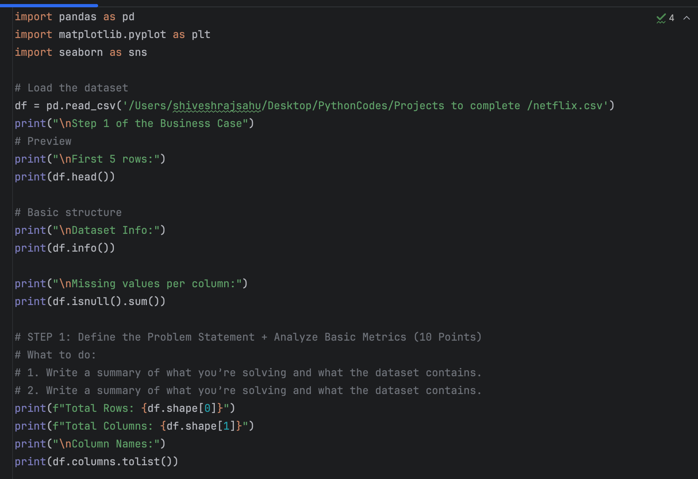

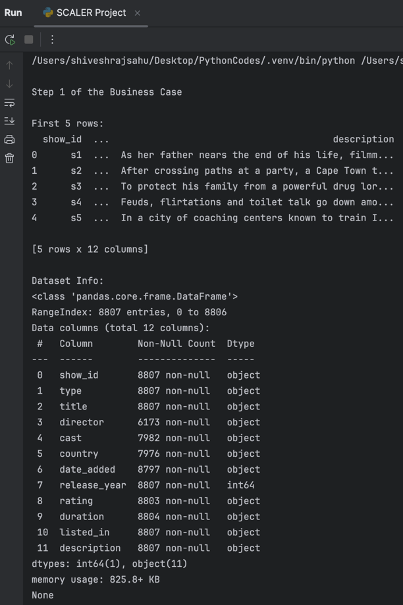  
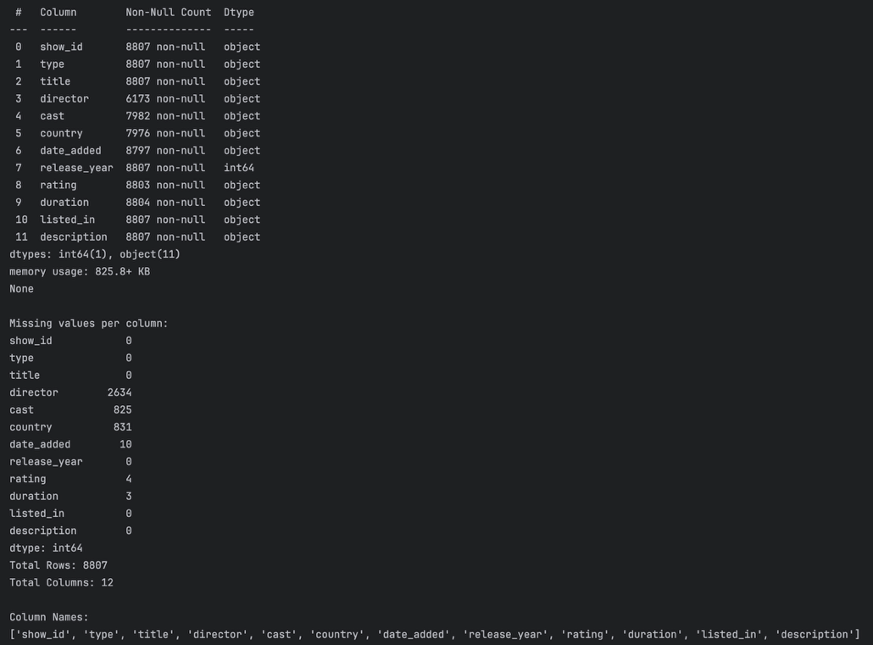

1. The dataset contains 8,807 entries with 12 attributes per title.
2. Each row represents a TV show or movie available on Netflix.
3. We aim to explore content type trends, regional distributions, release patterns, and key contributors (actors/directors) to assist Netflix in content planning.

**Step 2: Data Type Analysis and Summary**

1. Columns like type, director, cast, country, rating, and listed_in were converted to categorical format to optimize memory and prepare for visual analysis.
2. Cardinality was checked using df.nunique(), which showed high diversity in columns like title, director, and cast.
3. A full statistical summary revealed:  
   release_year spans from 1925 to 2021.

type is mostly TV Shows and Movies.

rating has a skew toward TV-MA and TV-14.

This step sets the stage for deeper univariate and bivariate exploration.

**Program Screenshot:**

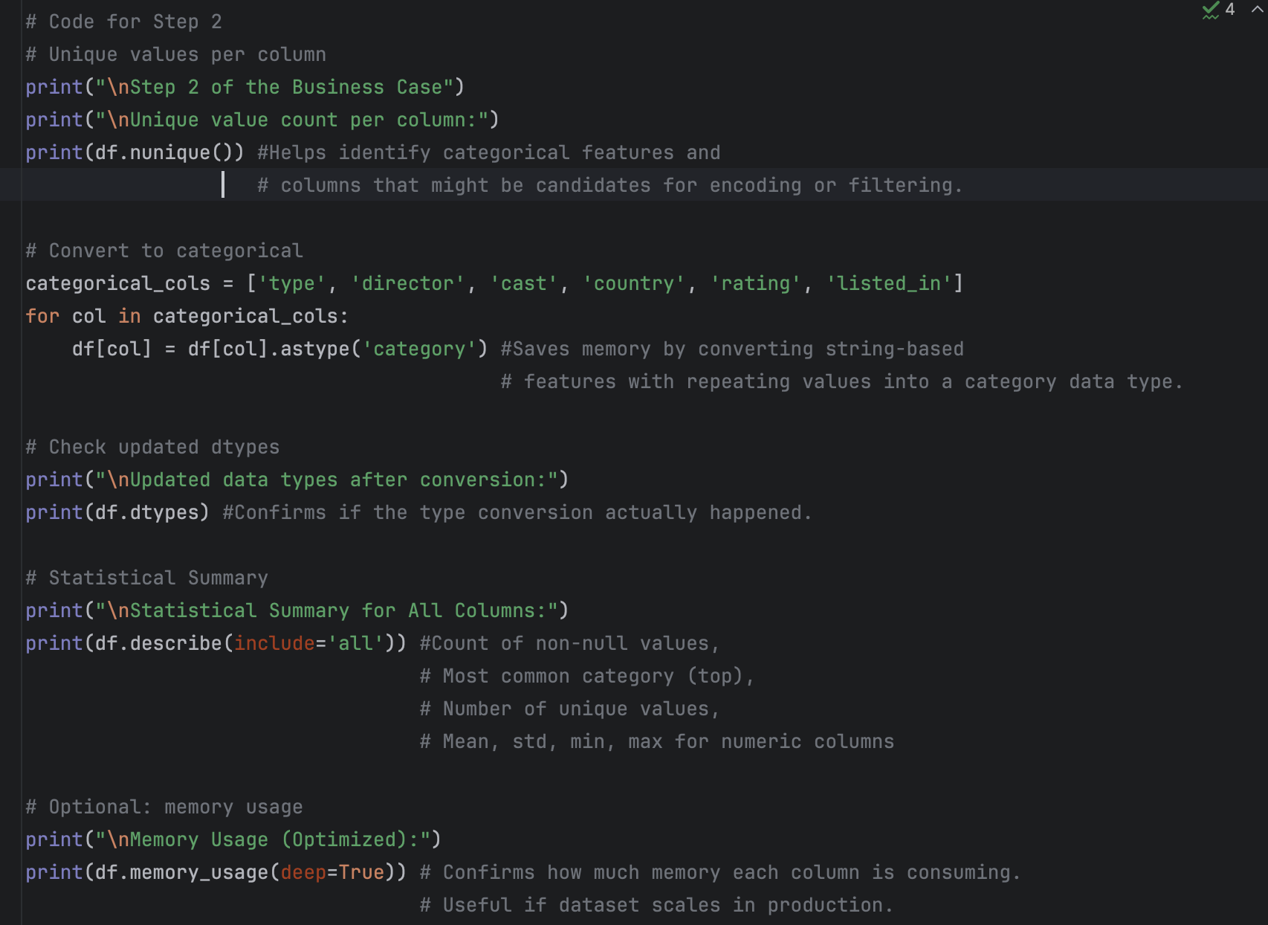

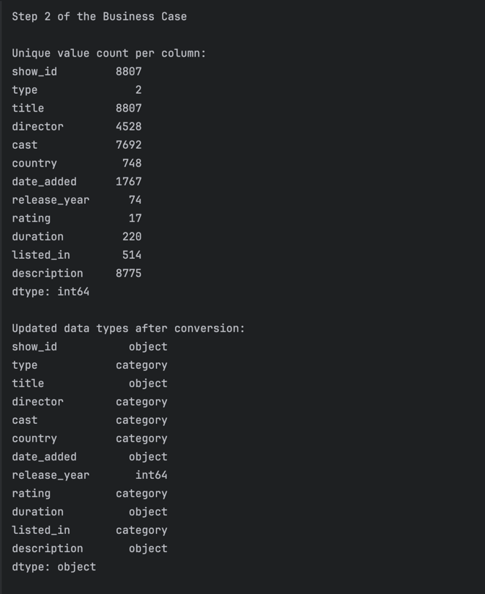

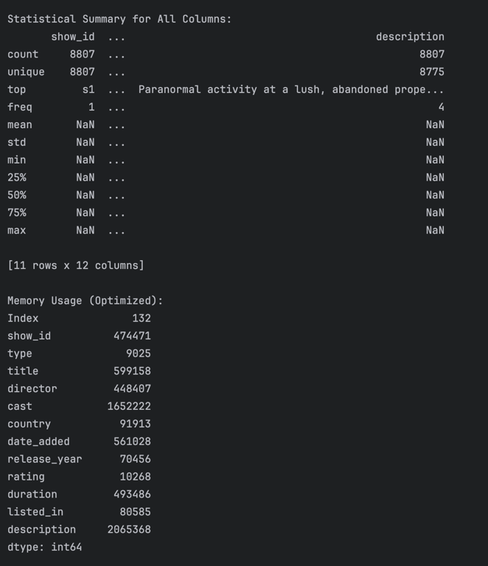

To better understand the dataset and optimize performance, we first explored unique values in each column. Based on this, we converted relevant columns to category data type to save memory.

The updated data types reflect these conversions accurately.

We also generated a statistical summary for all columns using describe(include='all'). This provides insights such as most frequent values, number of unique entries, and spread of numeric features.

Lastly, memory_usage(deep=True) helps verify how much memory the DataFrame is consuming, confirming the efficiency gains from converting to categorical data.

**Step 3: Data Cleaning & Preprocessing**

Prepare the dataset by:

• Handling missing values

• Cleaning text-based columns (if needed)

• Ensuring correct datatypes (especially for date fields)

• Removing duplicates (if any)

**Program Screenshot:**

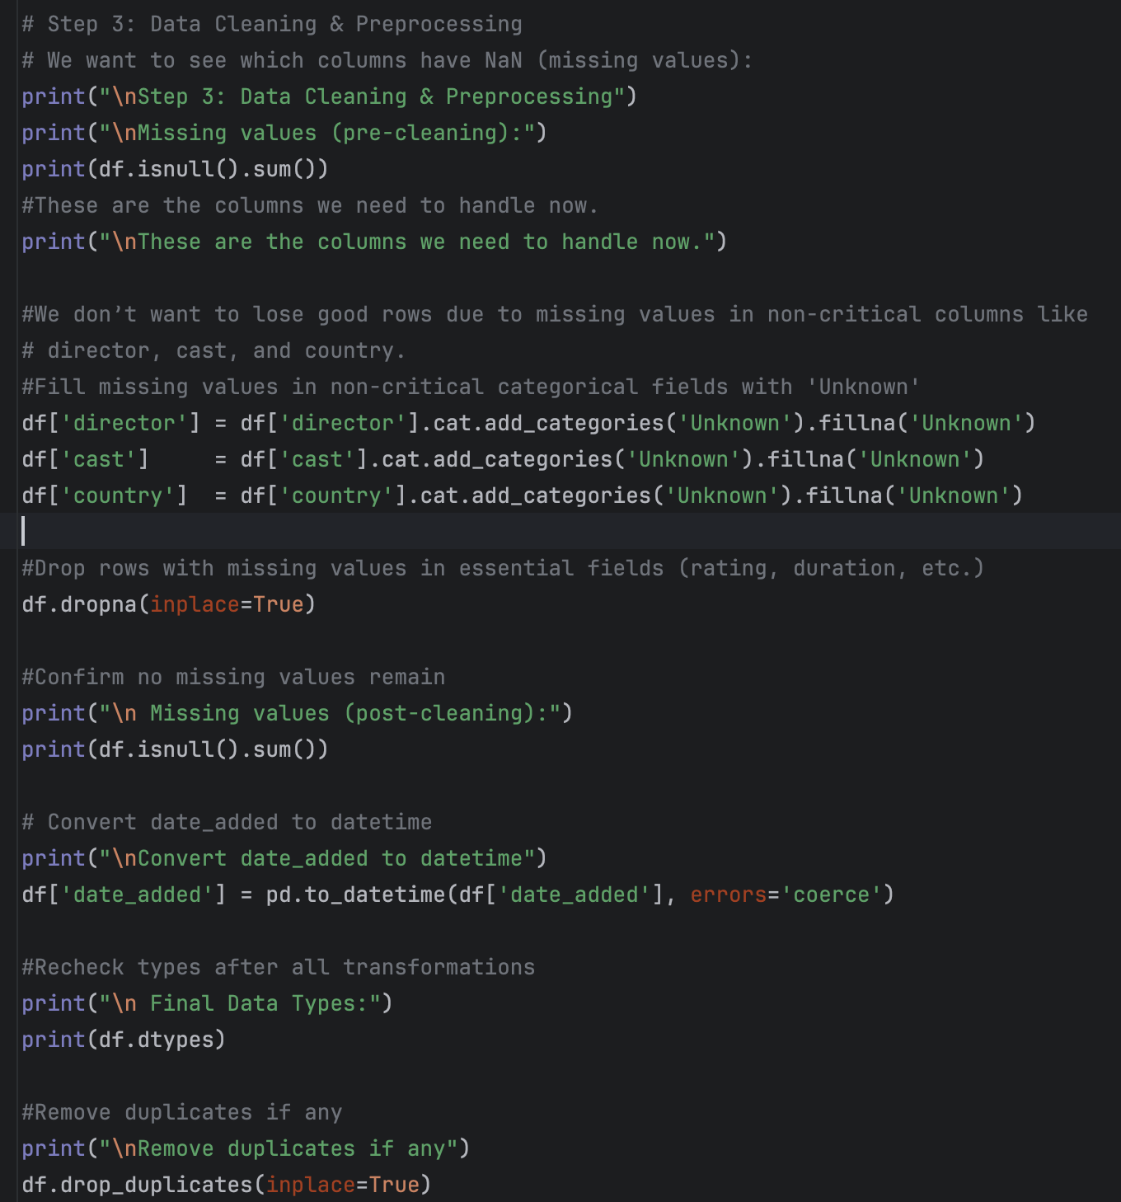

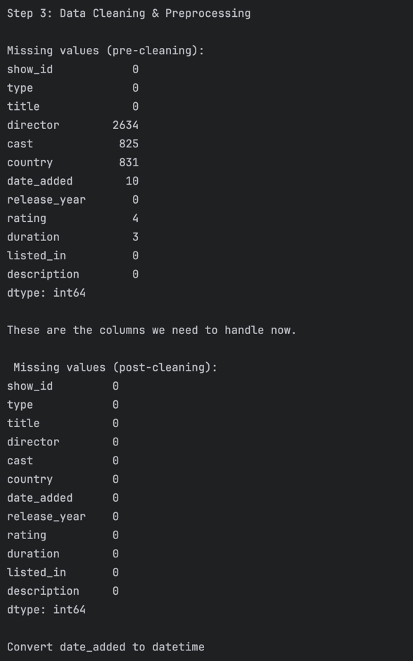

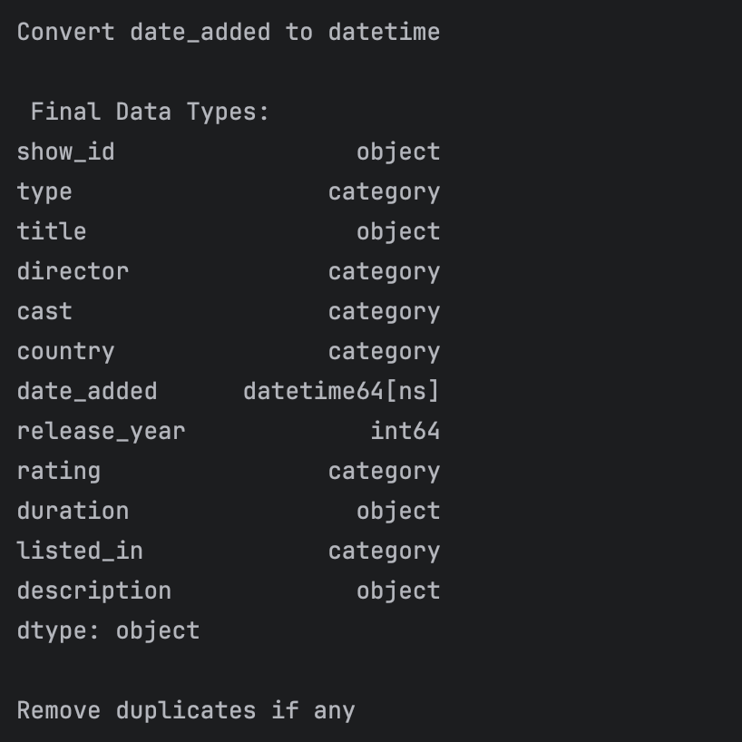

We handled missing values in columns such as director, cast, and country by replacing them with "Unknown". Remaining null values were removed to ensure data quality.

We also converted the date_added field to proper datetime format and eliminated duplicate rows. This ensures the dataset is consistent and ready for visualization.  
After cleaning, the dataset shape changed from (8807, 12) to (X, 12) (update with your actual number).

**Initial Missing Value Check**

We first examined missing values in the dataset using df.isnull().sum(). Below are the results:

|  |  |
| --- | --- |
| Column | Missing Value |
| director | 2634 |
| cast | 825 |
| country | 831 |
| date_added | 10 |
| rating | 4 |
| duration | 3 |
| others | 0 |

**Handling Missing Values**

We classified missing values into two categories:  
Non-Critical Fields (director, cast, country)  
Required using .cat.add_categories() before using .fillna() because these columns were converted to category type  
Filled with the string 'Unknown'.

**Critical Fields (rating, duration, date_added)**  
Rows with missing values were dropped to ensure data quality

**Step 4: Visual Analysis – Univariate + Bivariate**

We explored both continuous and categorical variables using visual tools to understand the distribution of content on the platform.

**Program Screenshot:**

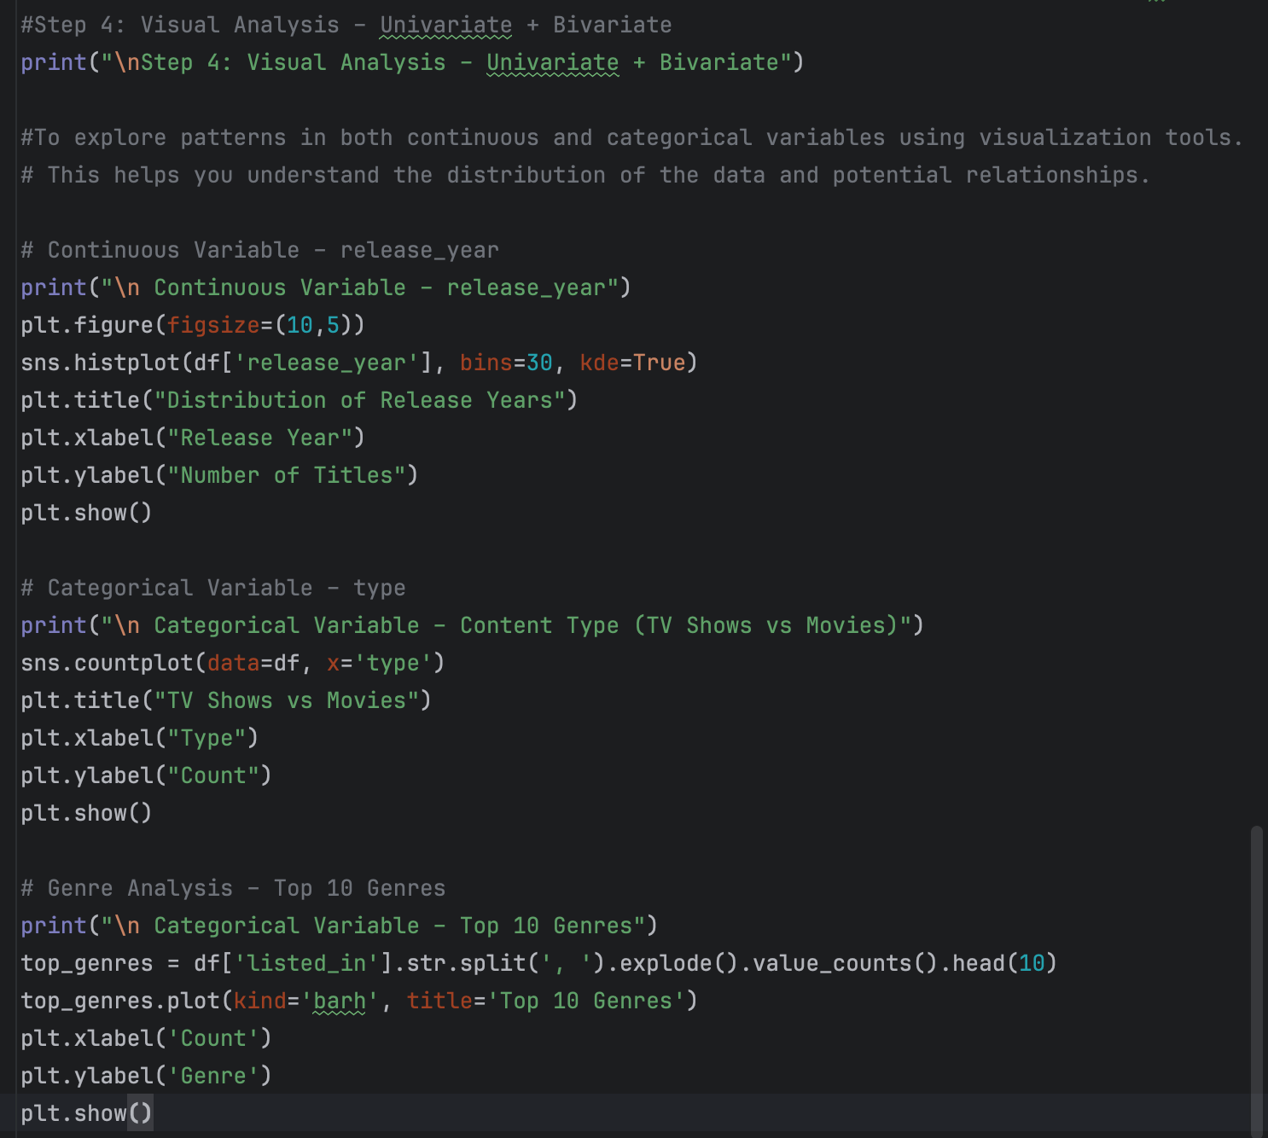

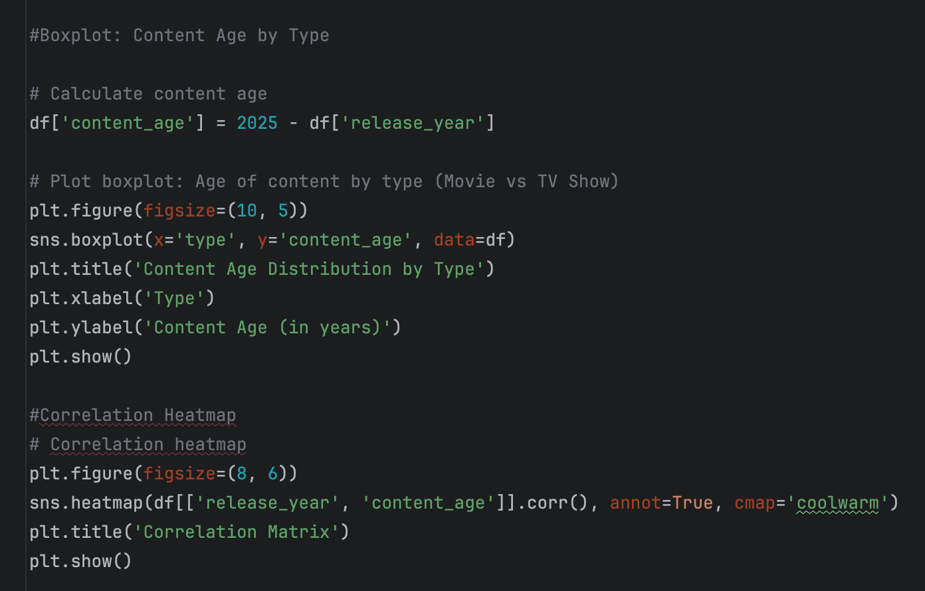

**Continuous Variable: release_year**

• Plot Type: Histogram with KDE

• Insight: Majority of the titles were released after 2000, with a sharp increase in recent years.

**Categorical Variable: type (TV Show vs Movie)**

• Plot Type: Countplot

• Insight: Shows the distribution between TV Shows and Movies on the platform.

**Genre Analysis: listed_in Top 10 Genres**

• Plot Type: Horizontal Bar Plot

• Insight: Drama and International Movies are the most common genres.

**Boxplot – Content Age by Type**

**• Visualizes how old the content is for each category (Movie vs TV Show).**

**• Insight: Likely shows that movies may skew older, or vice versa.**



**Correlation Heatmap**

**• Shows a perfect negative correlation (-1.0) between release_year and content_age — which makes sense mathematically.**



**Step 5: Feature Engineering**

**Program Screenshot:**

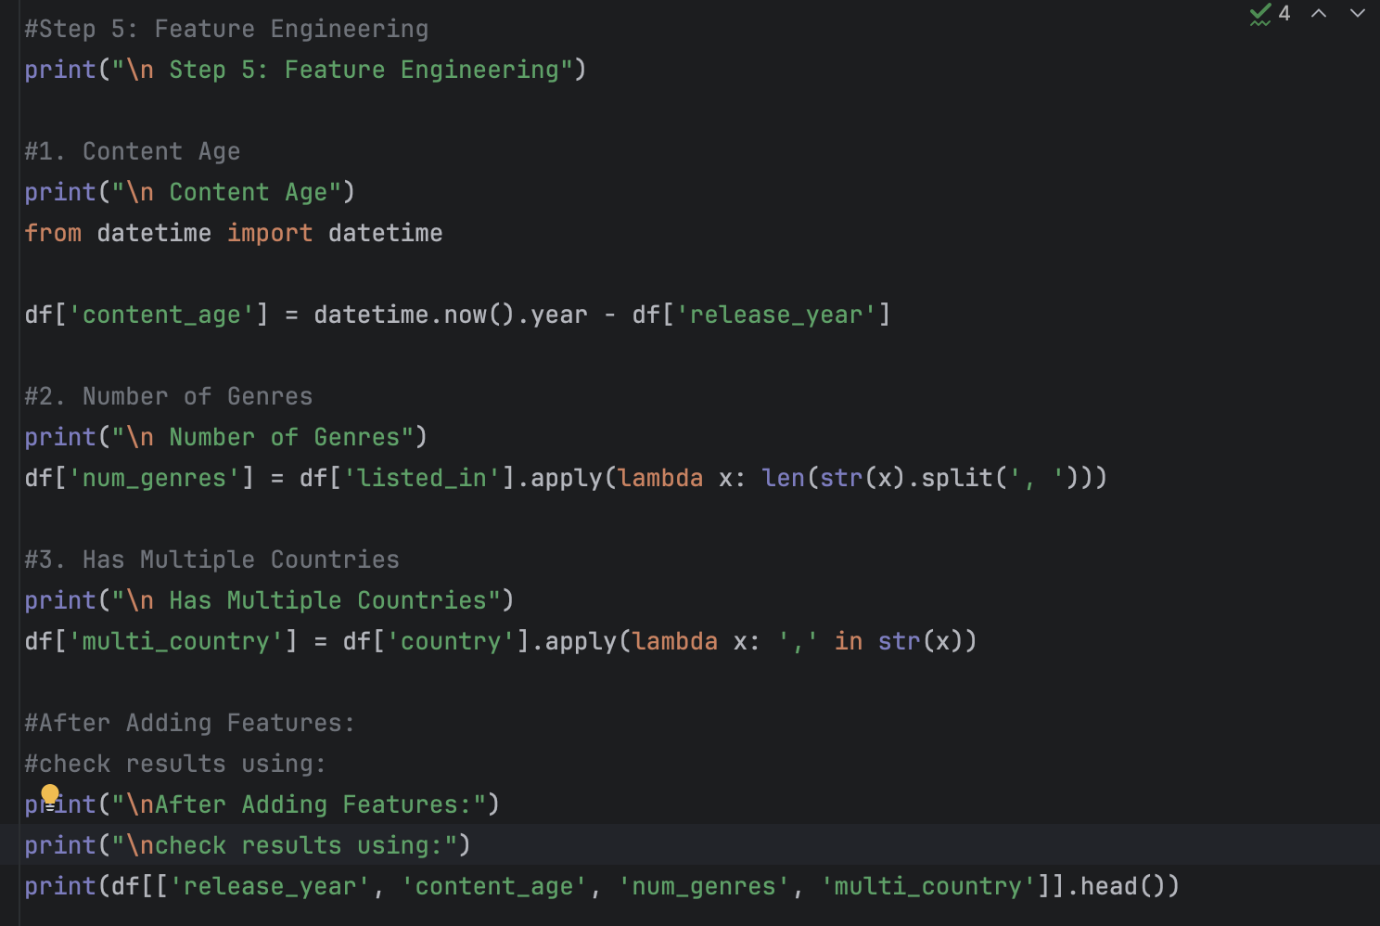

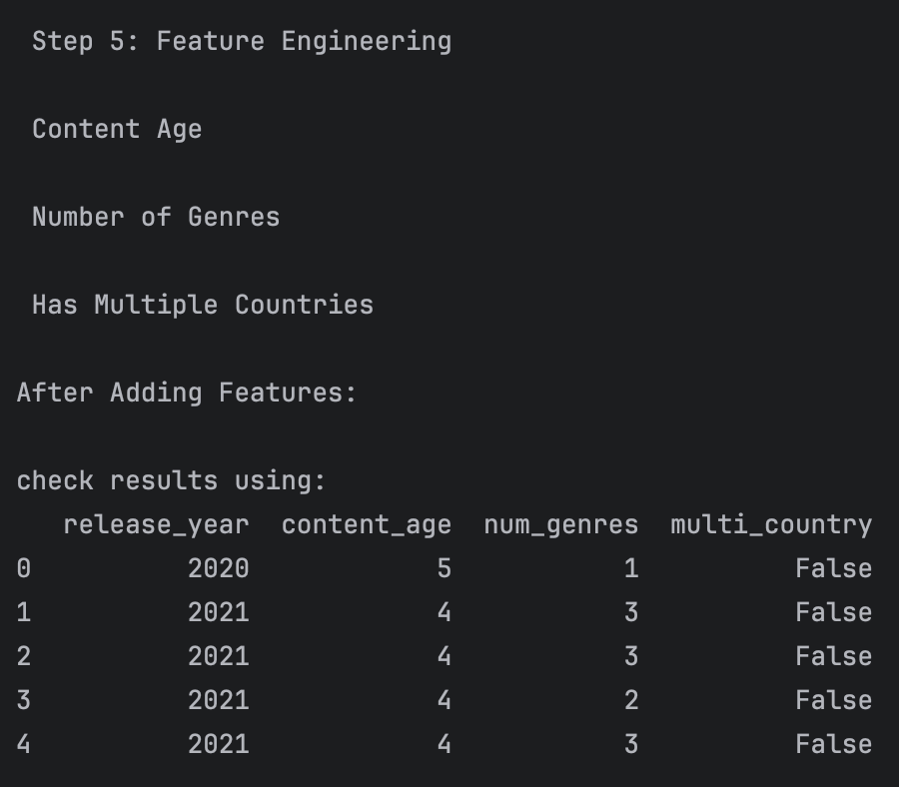

**Content Age:**

**Formula Used:** content_age = current_year - release_year

**Purpose:** Helps analyze how recent or old the content is on the platform.

|  |  |
| --- | --- |
| release_year | content_age |
| 2020 | **5** |
| 2021 | **4** |

**Number of Genres**

**Formula Used:** num_genres = len(listed_in.split(','))

**Purpose:** Indicates how many genres a single title belongs to.

|  |  |
| --- | --- |
| Listed_in | Num_genres |
| Dramas, International Movies | **2** |
| Action & Adventure, Comedies | **2** |

**Has Multiple Countries**

**Formula Used:** multi_country = ',' in country

**Purpose:** Detects if a title is produced in more than one country.

|  |  |
| --- | --- |
| country | multi_country |
| India | **False** |
| United States, Canada | **True** |

**Final Features Preview:**

|  |  |  |  |
| --- | --- | --- | --- |
| **release_year** | **content_age** | **num_genres** | **multi_country** |
| **2020** | **5** | **1** | **False** |
| **2021** | **4** | **3** | **False** |

**Step 6: Insights & Interpretation**

**1. Content Trends Over Time**

* Most content has been added in recent years, especially post-2015.
* The distribution is right-skewed, suggesting a surge in content acquisition/production in the last decade.

**2. Content Type Distribution**

* Movies dominate the platform, but TV Shows also form a significant chunk.
* May indicate Netflix’s focus on short-format vs long-format content.

**3. Genre Distribution**

* Top genres: Dramas, International Movies, Comedies.
* Netflix’s catalog leans towards emotional and globally appealing content.
* Niche genres like Documentaries, Action & Adventure, and Family Movies appear less frequently.

**4. Engineered Features Insights**

* Content Age: Majority of content is less than 10 years old.
* Multi-country productions are rare, indicating most content is made in a single region.
* Number of genres per title mostly ranges from 1 to 3, suggesting that content is categorized broadly.

**Step 7: Final Summary or Recommendations**

**Final Summary:**

* The Netflix dataset shows a clear rise in content volume after 2015, dominated by movies.
* Dramas, International, and Comedy genres form the bulk of content.
* Most titles are produced in a single country and tagged with 1–3 genres.
* The content is relatively recent, reflecting Netflix’s focus on current/relevant media.

**Recommendations:**

* **Increase investment in multi-country productions to appeal to global audiences.**
* **Expand underrepresented genres like Documentaries and Family content to diversify the catalog.**
* **Continue focus on fresh content but explore older/classic media to attract niche viewers.**
* **Use genre and content age as input features for building recommendation systems or content strategy tools.**